**Computer Organization And Architecture**

**Lab-4 -Loops**

**S Abhishek**

**AM.EN.U4CSE19147**

**1. Sample code for a loop to compute the sum of N integers: 1 + 2 + ... + N**

.data

input: .asciiz "Enter the Number of integers : "

output: .asciiz "Sum of (i) till (n) = "

.text

.globl main

main:

li $v0,4

la $a0,input

syscall

li $v0,5

syscall

move $t0,$v0

li $t1,0

li $t2,0

Continue:

addi $t1,$t1,1

add $t2,$t2,$t1

beq $t0,$t1,Quit

j Continue

Quit:

li $v0,4

la $a0,output

syscall

li $v0,1

move $a0,$t2

syscall

li $v0,10

syscall

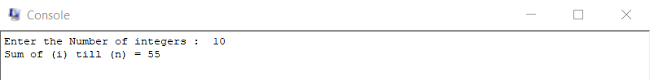

**2. Convert the following c-like code into MIPS assembly code.**

**if ( i == j )**

**i++ ;**

**j-- ;**

.data

input1: .asciiz "Enter ( i ) : "

input2: .asciiz "Enter ( j ) : "

output1: .asciiz "\n( i ) = "

output2: .asciiz "\n( j ) = "

prompt1: .asciiz "\nIf Executed\n"

prompt2: .asciiz "\nIf Not Executed\n"

.text

.globl main

main:

li $v0,4

la $a0,input1

syscall

li $v0,5

syscall

move $t0,$v0 #i

li $v0,4

la $a0,input2

syscall

li $v0,5

syscall

move $t1,$v0 #j

beq $t0,$t1,Increment

li $v0,4

la $a0,prompt2

syscall

j Exit

Increment:

li $v0,4

la $a0,prompt1

syscall

addi $t0,$t0,1

j Exit

Exit:

addi $t1,$t1,-1

li $v0,4

la $a0,output1 #Sample Checking of ( i )

syscall

li $v0,1

move $a0,$t0

syscall

li $v0,4

la $a0,output2 #Sample Checking of ( j )

syscall

li $v0,1

move $a0,$t1

syscall

li $v0,10

syscall

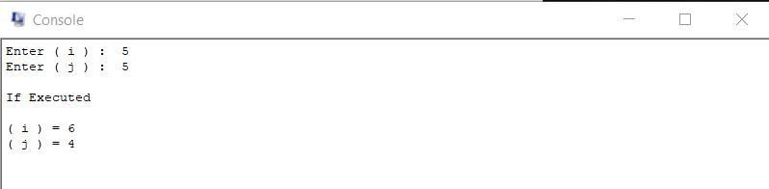

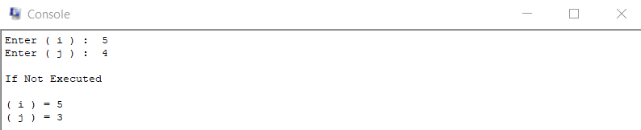

**3.Convert the following c-like code into MIPS assembly code.**

**if ( i == j )**

**i++ ;**

**else**

**j-- ;**

**j += i ;**

.data

input1: .asciiz "Enter ( i ) : "

input2: .asciiz "Enter ( j ) : "

output1: .asciiz "\n\n( i ) = "

output2: .asciiz "\n( j ) = "

output3: .asciiz "\n( j ) After Adding with ( i ) = "

prompt1: .asciiz "\nIf Executed\n"

prompt2: .asciiz "\nElse Executed\n"

.text

.globl main

main:

li $v0,4

la $a0,input1

syscall

li $v0,5

syscall

move $t0,$v0 #i

li $v0,4

la $a0,input2

syscall

li $v0,5

syscall

move $t1,$v0 #j

beq $t0,$t1,Increment

bne $t0,$t1,Decrement

Increment:

addi $t0,$t0,1

li $v0,4

la $a0,prompt1

syscall

li $v0,4 #Sample Checking of ( i )

la $a0,output1

syscall

li $v0,1

move $a0,$t0

syscall

li $v0,4 #Sample Checking of ( j )

la $a0,output2

syscall

li $v0,1

move $a0,$t1

syscall

j Exit

Decrement:

addi $t1,$t1,-1

li $v0,4

la $a0,prompt2

syscall

li $v0,4 #Sample Checking of ( i )

la $a0,output1

syscall

li $v0,1

move $a0,$t0

syscall

li $v0,4 #Sample Checking of ( j )

la $a0,output2

syscall

li $v0,1

move $a0,$t1

syscall

j Exit

Exit:

add $t1,$t1,$t0

li $v0,4 #Sample Checking of ( i )

la $a0,output1

syscall

li $v0,1

move $a0,$t0

syscall

li $v0,4 #Sample Checking of ( j )

la $a0,output3

syscall

li $v0,1

move $a0,$t1

syscall

li $v0,10

syscall

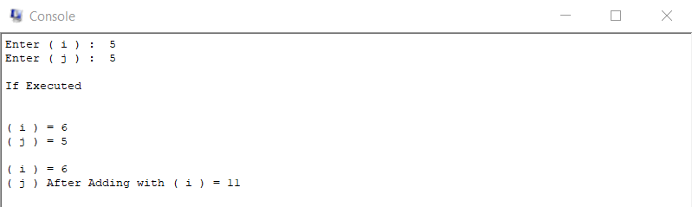

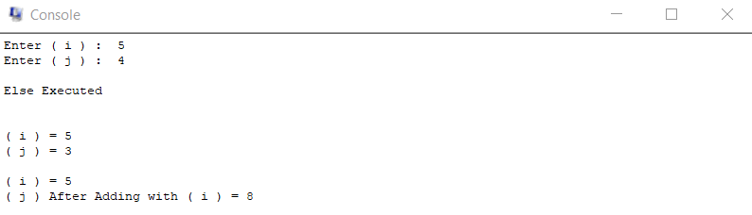

**4. Convert the following c-like code into MIPS assembly code.**

**if ( i == j && i == k )**

**j++ ;**

**i-- ;**

**else**

**j = i + k-2 ;**

.data

input1: .asciiz "Enter ( i ) : "

input2: .asciiz "Enter ( j ) : "

input3: .asciiz "Enter ( k ) : "

output1: .asciiz "\n( i ) = "

output2: .asciiz "\n( j ) = "

output3: .asciiz "\n( k ) = "

prompt1: .asciiz "\nIf Executed\n"

prompt2: .asciiz "\nElse Executed\n"

.text

.globl main

main:

li $v0,4

la $a0,input1

syscall

li $v0,5

syscall

move $t0,$v0 #i

li $v0,4

la $a0,input2

syscall

li $v0,5

syscall

move $t1,$v0 #j

li $v0,4

la $a0,input3

syscall

li $v0,5

syscall

move $t2,$v0 #j

bne $t0,$t1,Else

bne $t0,$t2,Else

li $v0,4

la $a0,prompt1

syscall

addi $t1,$t1,1

addi $t0,$t0,-1

j Exit

Else:

li $v0,4

la $a0,prompt2

syscall

addi $t1,$t0,0

addi $t3,$t2,-2

add $t1,$t1,$t3

Exit:

li $v0,4

la $a0,output1

syscall

li $v0,1

move $a0,$t0

syscall

li $v0,4

la $a0,output2

syscall

li $v0,1

move $a0,$t1

syscall

li $v0,4

la $a0,output3

syscall

li $v0,1

move $a0,$t2

syscall

li $v0,10

syscall

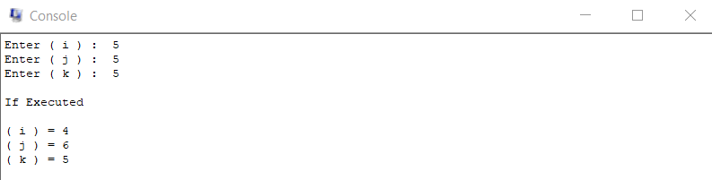

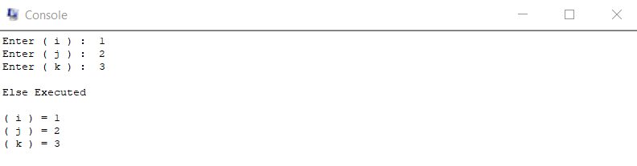

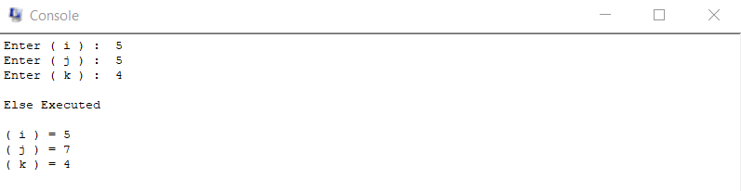

**5. Convert the following c-like code into MIPS assembly code.**

**if ( i==j || i==k )**

**i++ ;**

**j-- ;**

**else**

**j = i + k ;**

.data

input1: .asciiz "Enter ( i ) : "

input2: .asciiz "Enter ( j ) : "

input3: .asciiz "Enter ( k ) : "

output1: .asciiz "\n( i ) = "

output2: .asciiz "\n( j ) = "

output3: .asciiz "\n( k ) = "

prompt1: .asciiz "\nIf Executed\n"

prompt2: .asciiz "\nElse Executed\n"

.text

.globl main

main:

li $v0,4

la $a0,input1

syscall

li $v0,5

syscall

move $t0,$v0 #i

li $v0,4

la $a0,input2

syscall

li $v0,5

syscall

move $t1,$v0 #j

li $v0,4

la $a0,input3

syscall

li $v0,5

syscall

move $t2,$v0 #j

beq $t0,$t1,If

beq $t0,$t2,If

li $v0,4

la $a0,prompt2

syscall

add $t1,$t0,$t2

j Exit

If:

li $v0,4

la $a0,prompt1

syscall

addi $t0,$t0,1

addi $t1,$t1,-1

Exit:

li $v0,4

la $a0,output1

syscall

li $v0,1

move $a0,$t0

syscall

li $v0,4

la $a0,output2

syscall

li $v0,1

move $a0,$t1

syscall

li $v0,4

la $a0,output3

syscall

li $v0,1

move $a0,$t2

syscall

li $v0,10

syscall

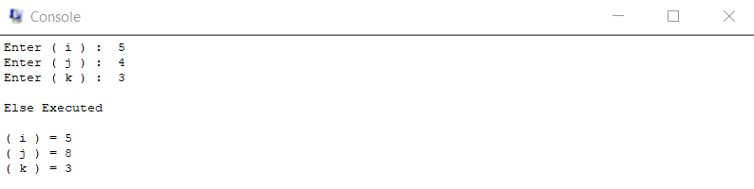

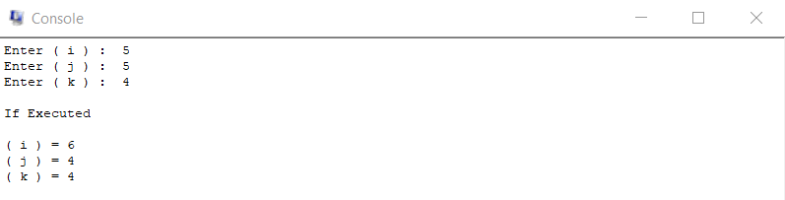

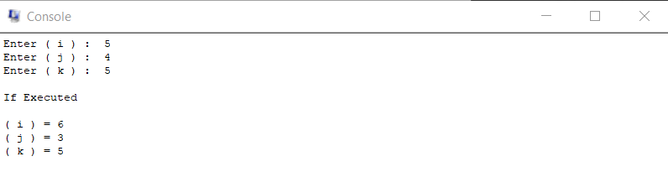

**Thankyou !!**